**LAB 06**

**TASK 1**

<https://leetcode.com/problems/merge-sorted-array/submissions/1410343228?envType=problem-list-v2&envId=sorting>

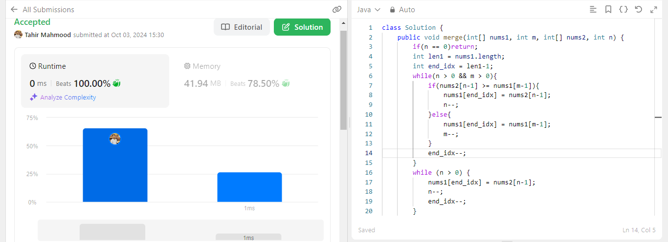

**TASK 2**

<https://leetcode.com/problems/intersection-of-two-arrays-ii/submissions/1410348445?envType=problem-list-v2&envId=sorting>

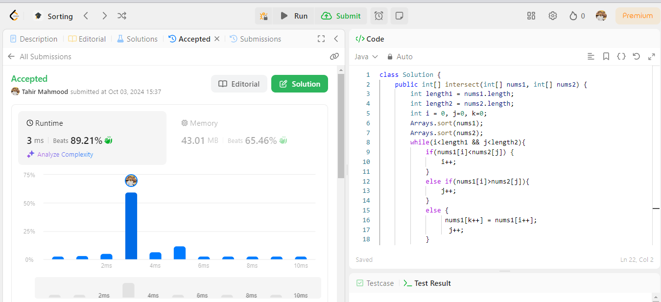

**TASK 3**

<https://leetcode.com/problems/find-the-difference/submissions/1414593475?envType=problem-list-v2&envId=sorting>

